Media Contact:
Catherine Hoy/Kristen Pirrocco
Frank Advertising
choy@frankadvertisingus.com
kpirrocco@frankadvertisingus.com

Top Knobs Presents the Pemberton Collection, A Balance of Tradition and Modernity

Branchburg, NJ – March 2026 – Top Knobs, the leading manufacturer of decorative kitchen and bath hardware, introduces the Pemberton Collection, a modern tribute to classic design. Pemberton reinvents timeless style through a modern heritage lens, with pieces that feature unique shapes, intricate detailing and eye-catching silhouettes.

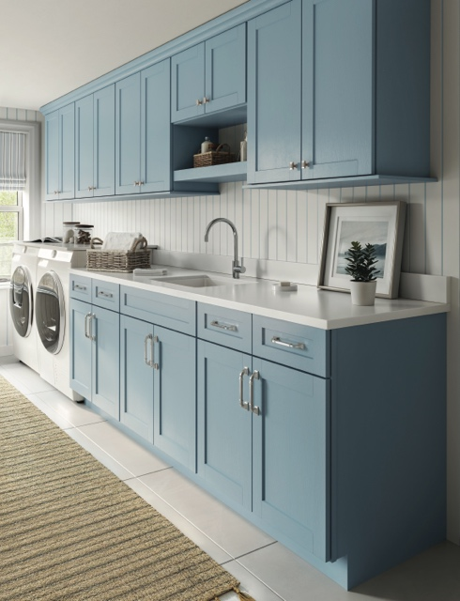
Califon knobs and pulls in Polished Chrome, Pemberton Collection

The Pemberton Collection features six distinctive suites, offering a versatile yet cohesive assortment of knobs, pulls, and appliance pulls. Rooted in classic design and reimagined with a modern heritage aesthetic, the collection blends timeless profiles with thoughtful detailing to bring depth and character to contemporary interiors. Pemberton introduces new 18” thin pulls, now available in two suites within the collection. These additions expand the collection with sleek, elongated silhouettes ideal for larger cabinetry and appliances.

“For over 30 years, Top Knobs has brought innovative and trend-setting styles to customers, and the Pemberton Collection is no exception,” states Christine Zimmer, Top Knobs’ Senior Director of Decorative Hardware. “A testament to our brand’s dedication to thoughtful design, Pemberton provides the ideal combination of classic, beloved styles with a contemporary, unique touch.”

Pemberton Collection Details:

- 336 pieces
- Six Suites: Bayridge, Califon, Elland, Lavington, Pemberton and Wetherby
- Knobs and T-Knobs available in Bayridge, Califon, Elland, Lavington and Pemberton ranging in size from 1 1/4" to 2 1/4"
- Pulls available in Bayridge, Califon, Elland, Lavington, Pemberton and Wetherby ranging in size from 3 3/4" c-c to 18” c-c.
- Appliance Pulls available in Bayridge, Califon, Elland, Lavington, Pemberton and Wetherby ranging in size from 12” c-c to 18” c-c.
- Finishes: Ash Gray, Flat Black, Brushed Satin Nickel, Honey Bronze, Polished Chrome, Polished Nickel

To download this press release and high-resolution images, click here.

To view the 2026 Top Knobs press kit, click here.

All Top Knobs collections come with a lifetime warranty. Visit TopKnobs.com for more information.

ABOUT TOP KNOBS
Top Knobs specializes in fine decorative hardware for the kitchen and bath. Designers value Top Knobs for their exceptional craftsmanship and attention to fine architectural detail – which is immediately apparent in the weighted feel and in the character of each hand-finished creation. Every cabinet knob, door handle, pull, hook or fixture by Top Knobs offers a completely sealed finish that lasts for years and years, so there’s not wear on the drawer knobs and pulls which are opened most. That’s why Top Knobs confidently offers an exclusive lifetime warranty for the original purchaser. They have over 4,500 kitchen, bath and closet designs, to match nearly every individual style and décor. Quality, craftsmanship, longevity and selection – “always the perfect opening.” 800-499-9095 www.TopKnobs.com.
# # #


