Contact: Catherine Hoy
Frank Advertising
732-644-3285
choy@frankadvertisingus.com

Top Knobs Defines the Next Era of Decorative Hardware with Design-Forward Innovations at KBIS 2026

Branchburg, NJ – January 2026 – Top Knobs, the leading manufacturer of decorative kitchen and bath hardware, returns to the Kitchen and Bath Industry Show (KBIS) with a curated exhibition of new and beloved collections that merge forward-thinking aesthetics with enduring craftsmanship. Through an immersive, all-encompassing display, Top Knobs celebrates the art of customization, where finishes, forms, shapes and textures converge to inspire highly personalized spaces.
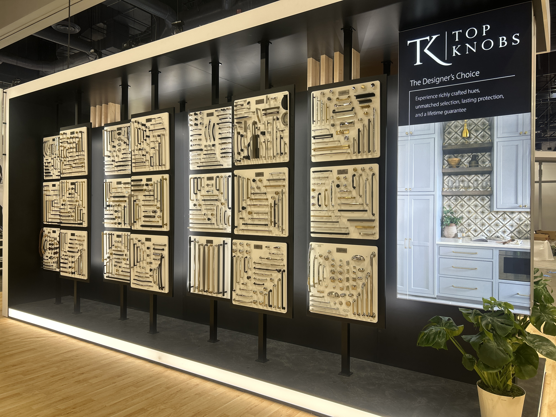
Taking place February 17–19, 2026, at the Orange County Convention Center in Orlando, Top Knobs invites designers and industry professionals to step inside Booth #W1742 for a dynamic product experience where timeless silhouettes meet contemporary sensibilities.
“At Top Knobs, we design with longevity in mind while continuously responding to how people live and interact with their spaces,” said Christine Zimmer, Senior Product Director at Top Knobs. “KBIS 2026 allows us to showcase new collections as well as how our breadth of suites empowers designers to personalize interiors with detail and intention.”
KBIS attendees can expect to preview the new collection inspired by modern heritage, a forward-looking perspective on emerging design trends and a closer look at the brand’s unmatched versatility.

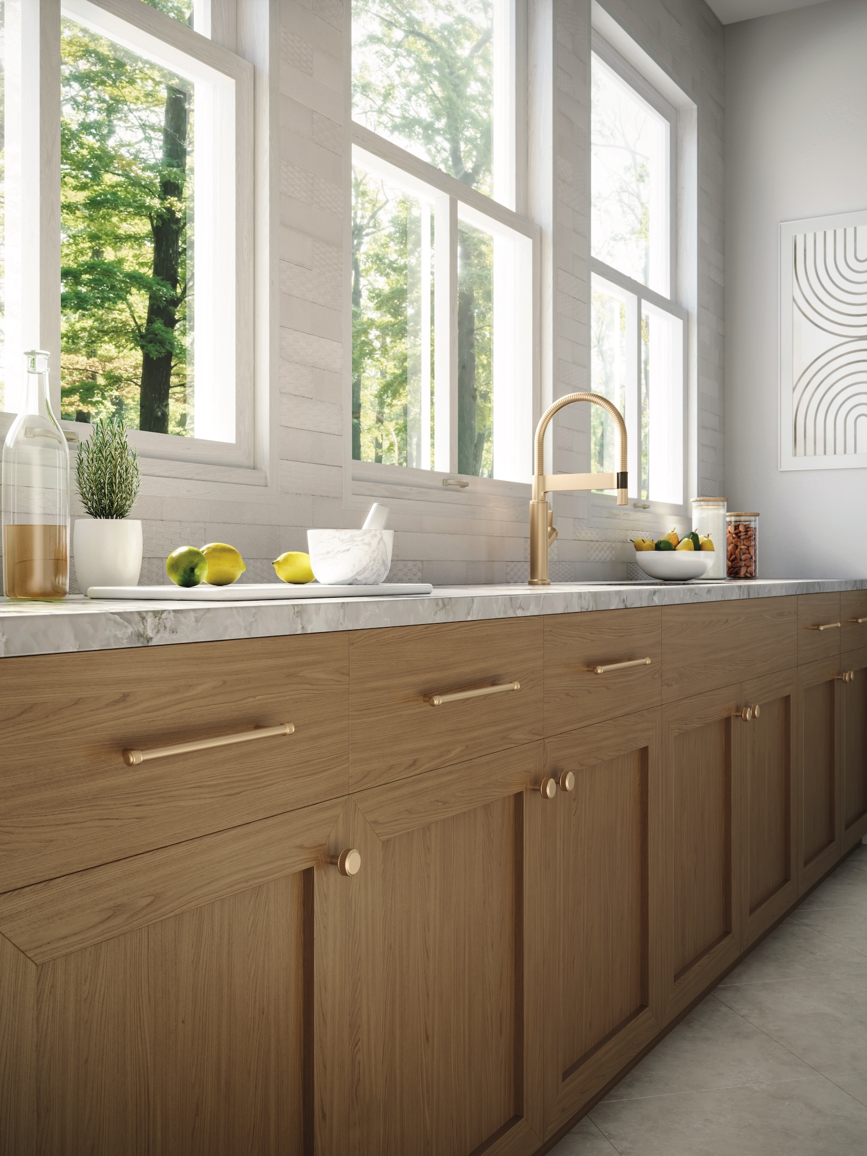
The Pemberton Collection
The Pemberton Collection reimagines timeless design through a modern heritage lens. Strong silhouettes and refined detailing honor classic nods, while sleek lines bring fresh sophistication. Complete with a variety of six suites, this collection balances tradition while creating spaces that feel both enduring and of-the-moment.
Suites include: Bayridge, Califon, Elland, Lavington, Pemberton and Wetherby.
Finishes include: Ash Gray, Flat Black, Honey Bronze, Polished Chrome and Polished Nickel
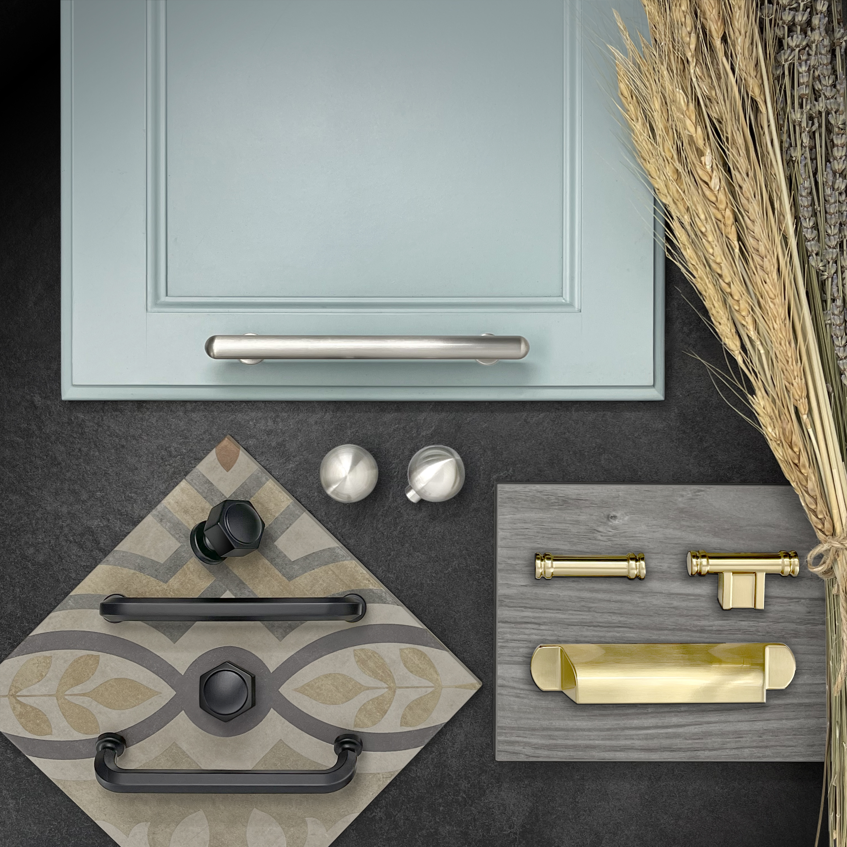
Trend Spotting

At KBIS 2026, Top Knobs brings a focused lens to the details driving today’s most compelling interiors. Through a considered mix of nuanced metal finishes, softened architectural silhouettes and thoughtfully evolved decorative fixtures, the presentation reflects a growing appetite for spaces that feel expressive and enduring, serving as a guide for design professionals shaping the next chapter of kitchen and bath settings.

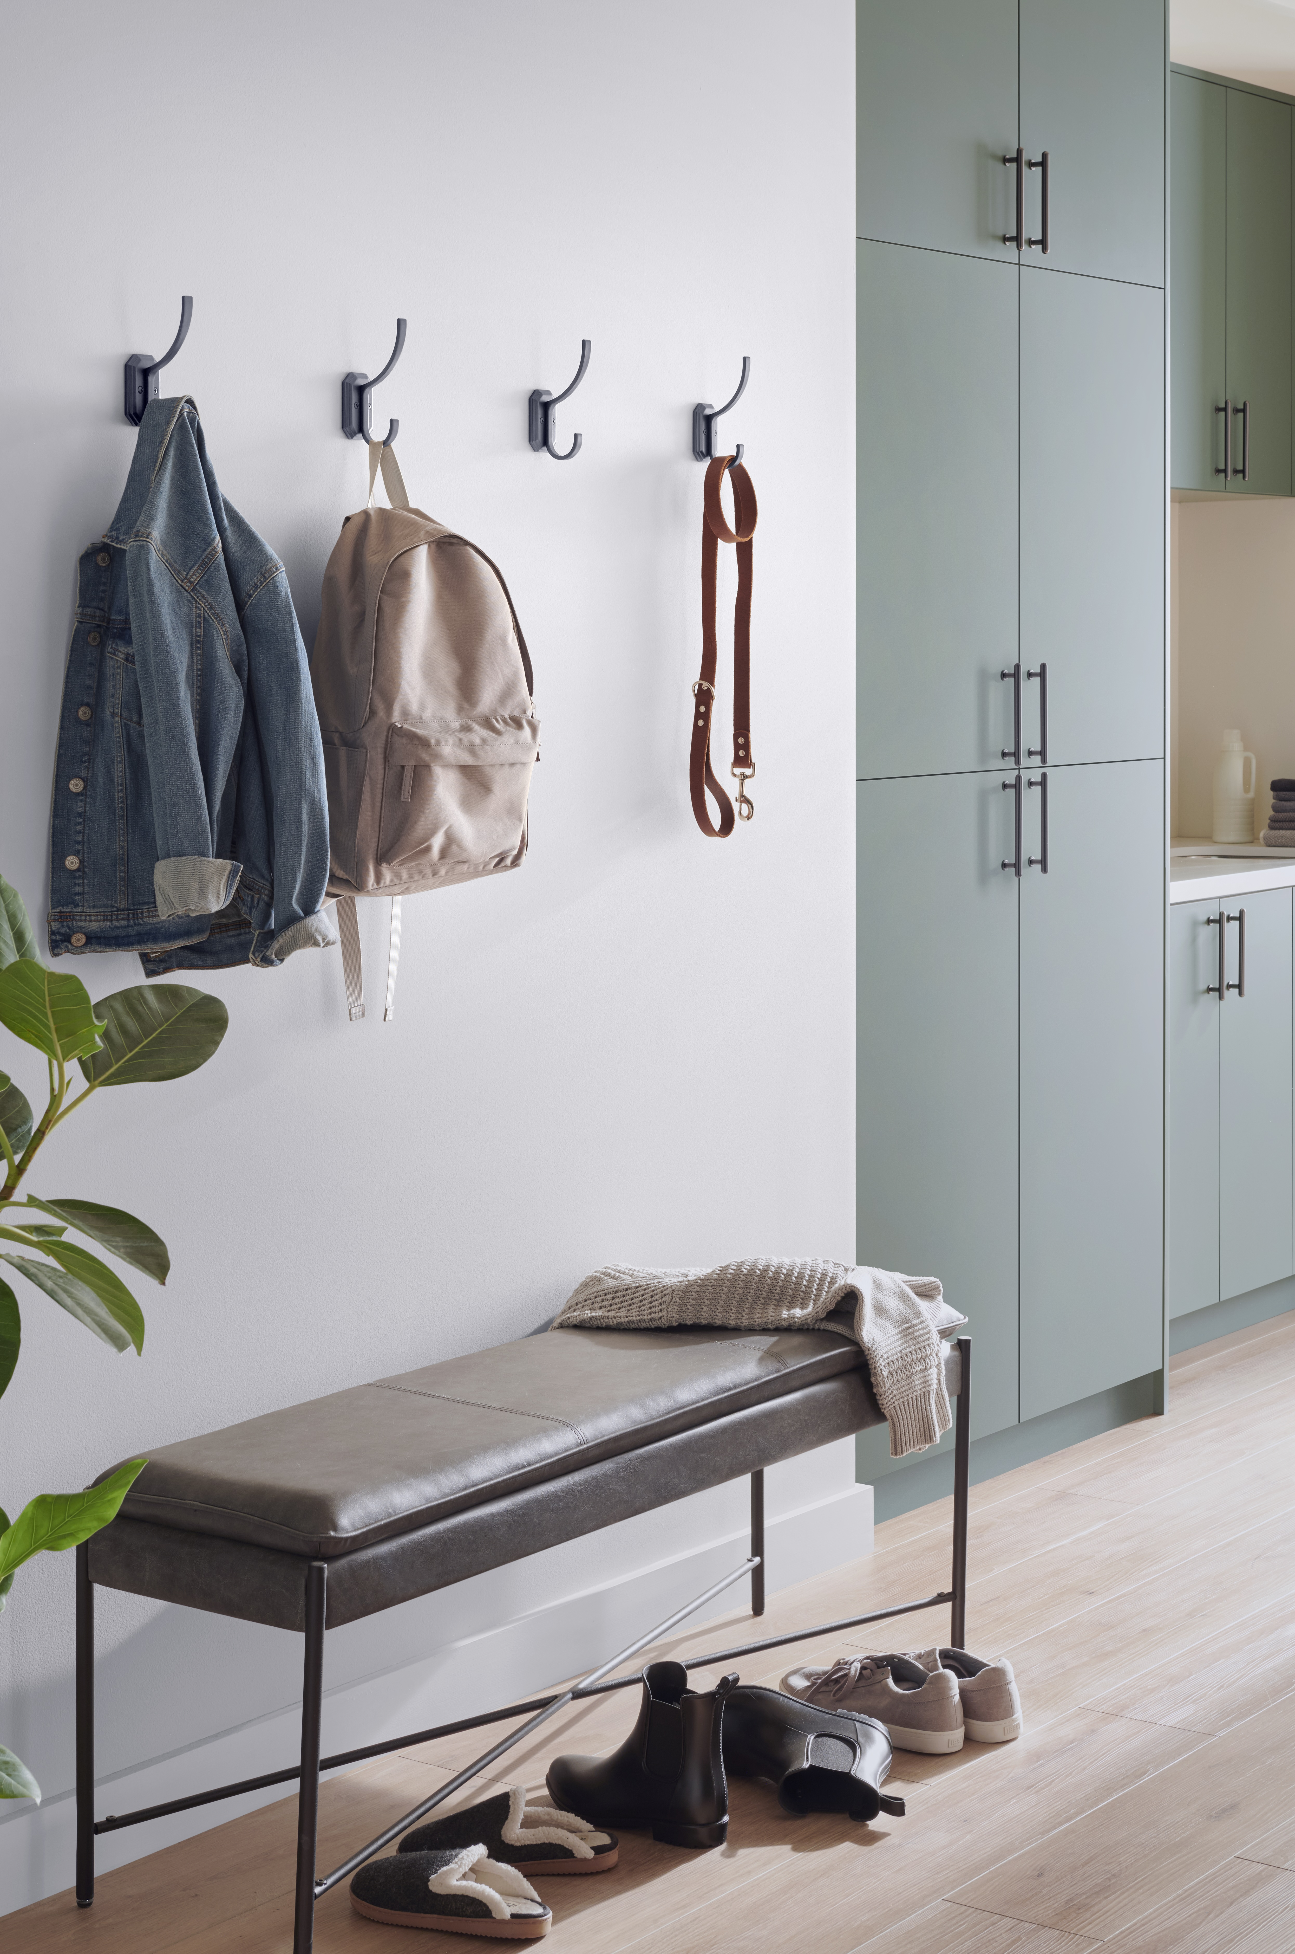

Customized Design Solutions

With more than 4,000 products, including an extensive selection of finishes, Top Knobs offers unparalleled flexibility for designers and homeowners alike. This expansive portfolio allows for a highly tailored styling approach, enabling cohesive design across kitchens, baths and other living spaces, or the intentional mixing of metals for a more distinctive look. From statement-making pieces to refined essentials, Top Knobs brings creative expression to the forefront of the decorative hardware realm, seamlessly balancing function, durability and elevated design.
To download this press release and high-resolution images, click here.
To browse the 2026 Top Knobs catalog, click here.

All Top Knobs collections come with a lifetime warranty. Visit TopKnobs.com for more information.

ABOUT TOP KNOBS
Top Knobs specializes in fine decorative hardware for the kitchen and bath. Designers value Top Knobs for their exceptional craftsmanship and attention to fine architectural detail – which is immediately apparent in the weighted feel and in the character of each hand-finished creation. Every cabinet knob, door handle, pull, hook or fixture by Top Knobs offers a completely sealed finish that lasts for years and years, so there’s not wear on the drawer knobs and pulls which are opened most. That’s why Top Knobs confidently offers an exclusive lifetime warranty for the original purchaser. They have over 4,500 kitchen, bath and closet designs, to match nearly every individual style and décor. Quality, craftsmanship, longevity and selection – “always the perfect opening.” 800-499-9095 www.TopKnobs.com.
# # #


