Case Study: History Meets Modernity with Top Knobs Hardware | Splendid Home Design
Location: Stuart, Florida
Designer: Bianca Fathauer
Project Name: Hibiscus House Revival
Photographer: Amanda James Photo
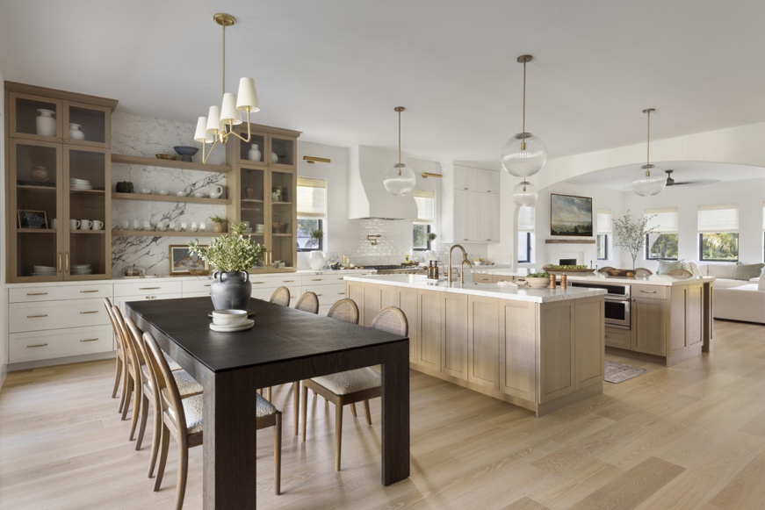
Photo Credit: Amanda James Photo
History Reinvented
Originally built in 1925 for one of the first doctors in Stuart, Florida, Hibiscus House is a historic residence that has been thoughtfully restored to celebrate its charming old Florida roots while introducing Mediterranean and Spanish Colonial influences. Designed as the heart of the home, the kitchen pairs quarter-sawn white oak cabinetry with white-painted perimeter cabinetry, natural marble countertops, a custom plaster range hood, and integrated appliances. By layering warm wood tones, timeless materials, and refined details, the Splendid Home Design team created a space that feels both collected and sophisticated while honoring the historic character and rich heritage of the home.
Drawing inspiration from both the home’s storied history and the personality of its current residents, the Splendid Home Design team created a home that feels deeply personal while still honoring the original home’s roots. Among the home’s many thoughtful design details of layered warm woods, natural stone and handcrafted finishes, the selection of hardware styles served as a defining design detail.
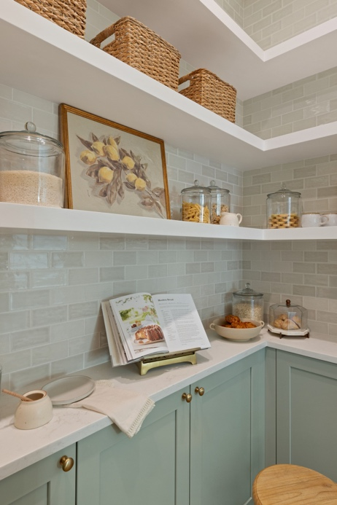
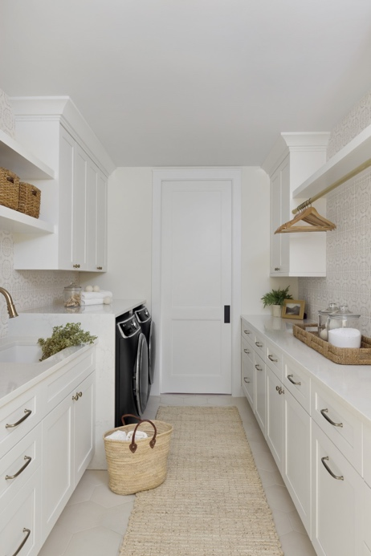

Photo Credit: Amanda James Photo
Details That Touch
Top Knobs hardware can be found throughout nearly every space in the home, from the kitchen and pantry to the office and mudroom. As one of the few design elements interacted with daily, hardware must provide the perfect balance of function and beauty. The Splendid Home Design team selected Top Knobs hardware for its exceptional craftsmanship, timeless profiles and extensive portfolio of coordinating collections. The hardware selection curates a cohesive design language throughout the entire home while allowing each space to maintain its own distinct personality. From painted cabinetry and quarter-sawn white oak to fluted light oak millwork, Top Knobs complements every cabinetry style, adding an elevated yet intentional touch to the design.
For this home, the design team selected four of Top Knobs’ suites, incorporating hardware across 11 different spaces. A mix of the knobs and pulls from the Charlotte, Hollow, Kinney and Cumberland suites brings together a balance of classic and contemporary influences, making it especially well suited to the restoration of this historic home. Throughout the home, all the hardware is in Top Knobs’ Honey Bronze finish. As one of Top Knobs’ best-selling finishes, Honey Bronze offers a chic twist on classic bronze and brass finishes, bringing a sense of warmth, comfort, and glamour to the interior of this home.

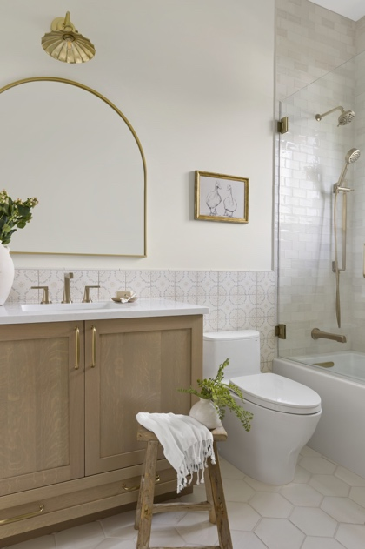
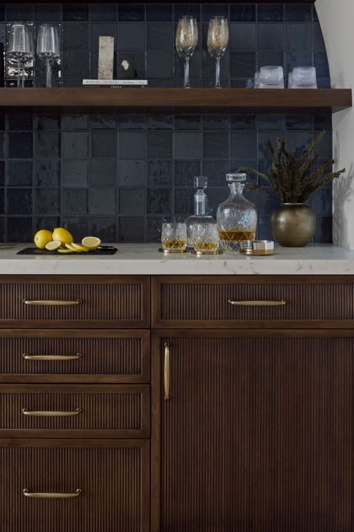

Photo Credit: Amanda James Photo

The Designer’s Prospective
"Every project begins with listening,” states Bianca Fathauer, Founder and Principal Designer of Splendid Home Design. “The Hibiscus Project was designed to reflect our clients' lifestyle while honoring the home's historic character. Thoughtfully selected hardware became one of the finishing details that connected every room with warmth, craftsmanship, and a sense of continuity."
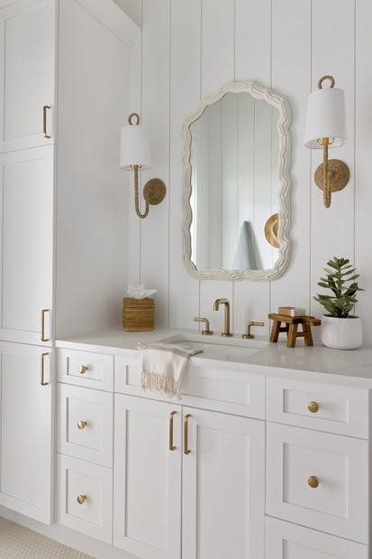
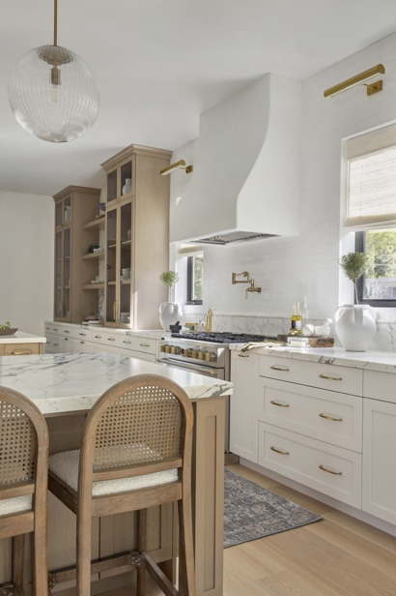

Photo Credit: Amanda James Photo
Finishing Details
Throughout the home, Top Knobs hardware ties each space together while highlighting the unique personality of each room. From the inviting brass accents in the kitchen and pantry to the fluted bar cabinetry and light oak vanities of the primary bath, the hardware serves as the perfect finishing touch to unify home’s historic charm with today’s modern luxury.

