Case Study: Elevated Finishing Touches with Top Knobs Hardware | Honeycomb Home Design
Location: Templeton, California
Designer: Honeycomb Home Design
Project Name: Rustic Revival
Photographer: Lisa Maksoudian

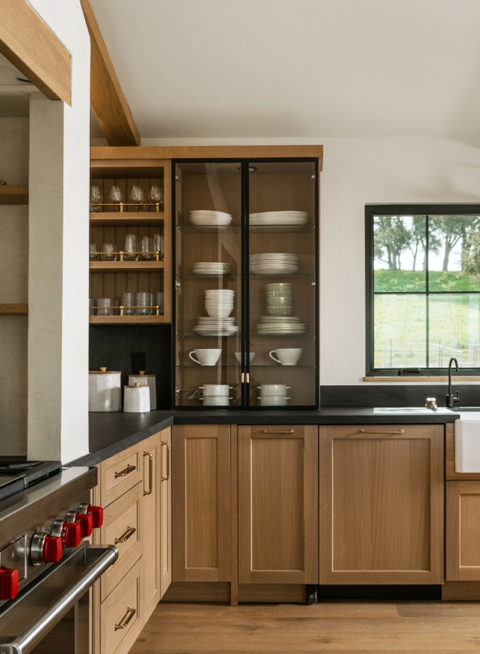
Photo Credit: Lisa Maksoudian

Rustic Warmth Reimagined

Located in the charming town of Templeton, California, this home serves as a welcoming retreat. Defined by a sense of quiet luxury that’s carried seamlessly from space to space, the home was refreshed with a warm, modern sensibility that feels elevated yet lived in. With the kitchen as the true heart of the home, the space features natural textures, thoughtful craftsmanship and soft, grounded tones that create an inviting central gathering space. Adjoined by the living and dining rooms, these spaces showcase layered materials and cozy woodwork, curating an atmosphere that’s both relaxed and deeply connected to the surrounding landscape. This ambiance flows throughout the home, where each room balances comfort, simplicity, and elegance, letting the architecture, light, and setting shine.

Drawing inspiration from modern Scandinavian design, this residence blends natural materials, rustic accents and contemporary finishes to create the perfect warm and welcoming home. Key textures throughout the space include lime wash plaster range hoods and fireplaces, rustic stone accent walls and smooth stucco, all contributing to the home’s sophisticated, refined and inviting atmosphere.

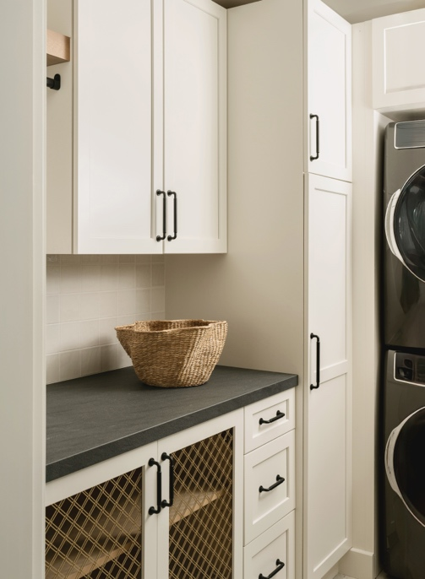
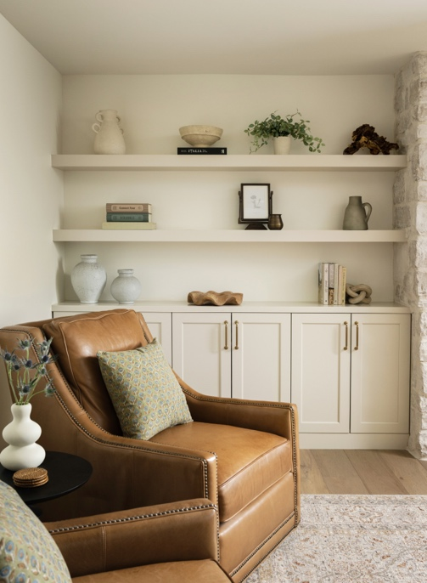

Photo Credit: Lisa Maksoudian

Elevated Finishing Touches

The team at Honeycomb Home Design was intentional with every detail, selecting pieces that feel grounded, textural and quietly elevated. Top Knobs was the natural choice for this project, as the hardware brings together clean lines, substantial weight and handcrafted finishes that beautifully complement the space. With a diverse variety of layered details throughout the home, the homeowners and designers craved hardware that enhanced the palette without competing with it, and the refined simplicity of Top Knobs’ pieces paired seamlessly with the home’s organic character.

For this residence, the Honeycomb Home Design team chose a mix of the Lily Pull in Flat Black and the Charlotte Pull in Honey Bronze. Both styles feature rounded, contemporary silhouettes that bring a polished edge to the interiors while still maintaining its natural character.

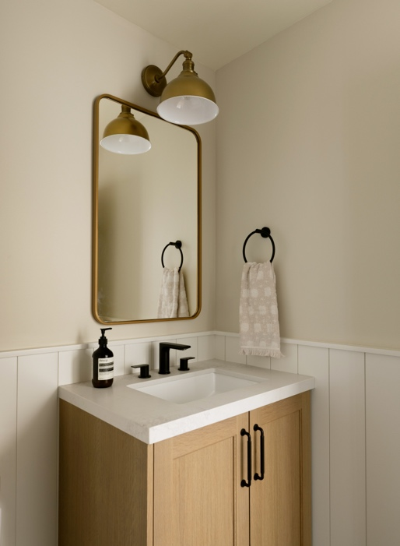
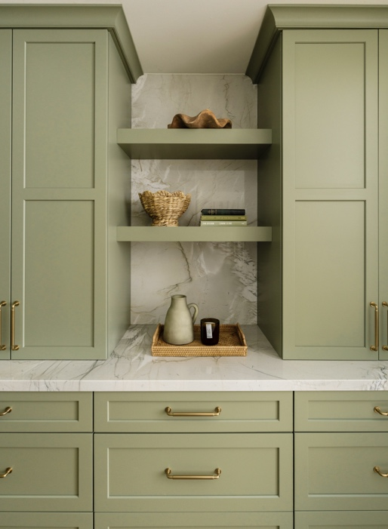

Photo Credit: Lisa Maksoudian

The Designer’s Perspective

“We return to Top Knobs again and again because their quality is felt immediately: solid construction, consistent finishes, and silhouettes that age gracefully,” states Ariana Lovato, Principal of Honeycomb Home Design. “In this project, their hardware became the quiet thread that ties cabinetry, built‑ins, and millwork together, subtle, intentional, and built to last.”

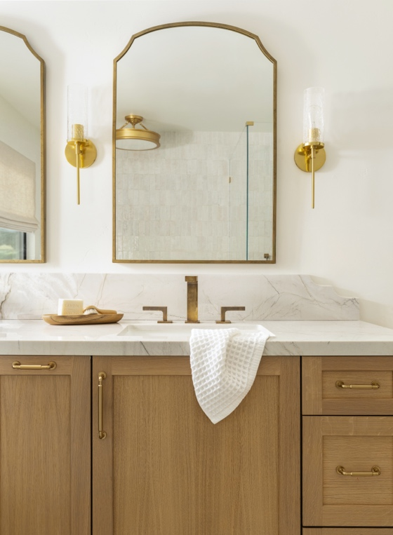
Photo Credit: Lisa Maksoudian

The Perfect Complement

The Honeycomb Home Design team ensures that every Honey Cabinetry installation feels complete, and in this project, the hardware became far more than just a functional detail. For Rustic Revival, the cabinetry already carried a strong sense of warmth and artistry, but the addition of the hardware gave the project its finished, intentional presence. Top Knobs’ pieces serve as the ideal complement, as they are structured without being heavy, refined without feeling precious and timeless enough to fit in the home for years to come.

Top Knobs offered the perfect details to complete this project, tying together the millwork, updated finishes and natural materials and providing the cabinetry with a sense of refinement and purpose.

To download high-resolution images, click here.

To view the 2026 Top Knobs press kit, click here.

