
July 2026
Caitlin Koch
Frank Advertising
ckoch@frankadvertisingus.com

Atlas Homewares Elevates Cabinetry Design with Three New Hardware Collections

Branchburg, NJ – Atlas Homewares, the vibrant decorative hardware company, proudly introduces Ballina, Fielding and Lannis, three thoughtfully designed collections that celebrate craftsmanship and enduring style. Each collection offers a distinct design, from understated refinement to bold geometric expression, giving homeowners, designers and builders the ability to personalize spaces with individuality and sophistication.

“Ballina, Fielding and Lannis are fresh, versatile hardware options that elevate today’s cabinetry,” says Christine Zimmer, Product Manager at Atlas Homewares. “Each collection offers its own unique personality while delivering the quality and craftsmanship Atlas Homewares is known for.”

Ballina Collection Details

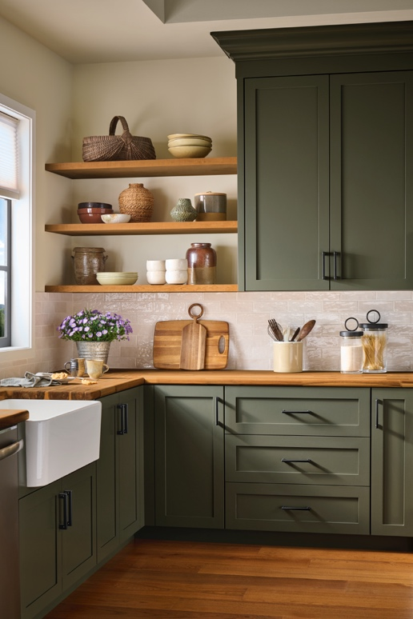

Designed with a balance of subtle roundness and crisp geometry, the Ballina Collection creates a look that feels both grounded and graceful. Strength in every line is complemented by softness in every curve, resulting in a collection that seamlessly blends modern and transitional design styles.

- 48 collection pieces
- Pulls available in sizes ranging from 3-3/4” c-c to 12” c-c
- Appliance pulls available in sizes 12” c-c and 18” c-c
- Finishes: Brushed Nickel (BRN), Matte Black (BL), Polished Chrome (CH), Polished Nickel (PN), Slate (SL) and Warm Brass (WB)

Fielding Collection Details

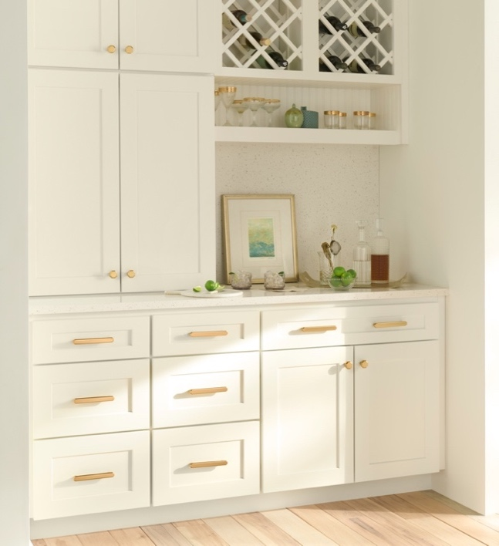

Bold, architectural and effortlessly modern, the Fielding Collection brings structure and refined edge to contemporary interiors. Defined by eight precise angles and one striking silhouette, the collection creates visual interest while maintaining a clean, minimalist aesthetic.

- 54 collection pieces
- Pulls available in sizes ranging from 3-3/4” c-c to 12” c-c
- Appliance pulls available in sizes 12” c-c and 18” c-c
- Knob is available in 1-1/4” size
- Finishes: Brushed Nickel (BRN), Matte Black (BL), Polished Chrome (CH), Polished Nickel (PN), Slate (SL) and Warm Brass (WB)

Lannis Collection Details

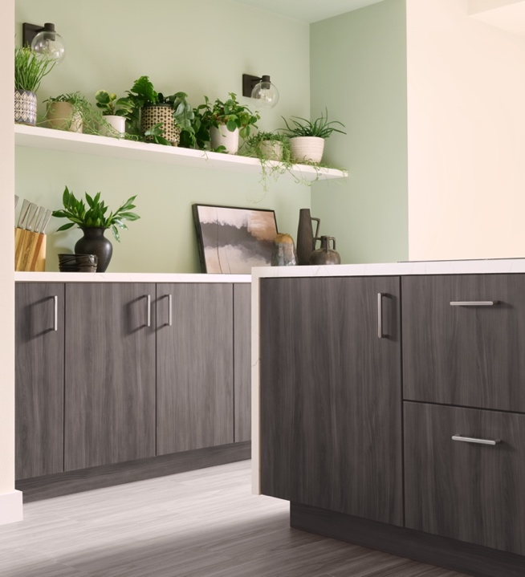

Defined by its sculpted silhouette and graceful curves, the Lannis Collection brings effortless softness to cabinetry while making a confident design statement. Subtle in shape yet strong in presence, its refined form creates the perfect balance of elegance and impact, making it an ideal finishing touch for both modern and transitional spaces.

- 54 collection pieces
- Pulls available in sizes ranging from 3-3/4” c-c to 12” c-c
- Appliance pulls available in sizes 12” c-c and 18” c-c
- Knob is available in 1-1/4” size
- Finishes: Brushed Nickel (BRN), Matte Black (BL), Polished Chrome (CH), Polished Nickel (PN), Slate (SL) and Warm Brass (WB)

To access the full Atlas Homewares 2026 press kit, click here.

ABOUT ATLAS HOMEWARES

Since 1993, Atlas Homewares has been recognized by industry professionals and consumers as the go-to decorative hardware collection to bring fashion and style into a home. Atlas Homewares has been named numerous times as one of the Top 10 Preferred Decorative Hardware Brands by Kitchen & Bath Business magazine.

Over the past three decades, Atlas Homewares has introduced many top-selling collections that are featured in showcase houses and high-design installations nationally and internationally. The brand's impassioned designs are a collective expression of the team's love for architecture and fashion. Inspiration can come from the texture of leather, a bauble, a piece of coral or elements that many would overlook. Yet our team turns these design details into decorative hardware that makes a difference.

Atlas Homewares products are available through professional kitchen and bath showrooms across the United States and Canada. https://www.atlashomewares.com/

