
March 2026
Caitlin Koch
Frank Advertising
ckoch@frankadvertisingus.com

Atlas Homewares Elevates Transitional Design with Amplify Collection

Branchburg, NJ – Atlas Homewares, the vibrant decorative hardware company, is proud to introduce its latest collection, Amplify. Thoughtfully designed to complement transitional spaces, Amplify strikes a refined balance between industrial edge and classic design.

“The Amplify Collection makes a subtly powerful statement,” says Christine Zimmer, Product Manager at Atlas Homewares. “It captures the boldness of industrial design while integrating effortlessly into transitional spaces. Additionally, its ergonomic design ensures a comfortable, soft-to-the-touch feel, perfect for everyday use.”

Amplify Collection Details
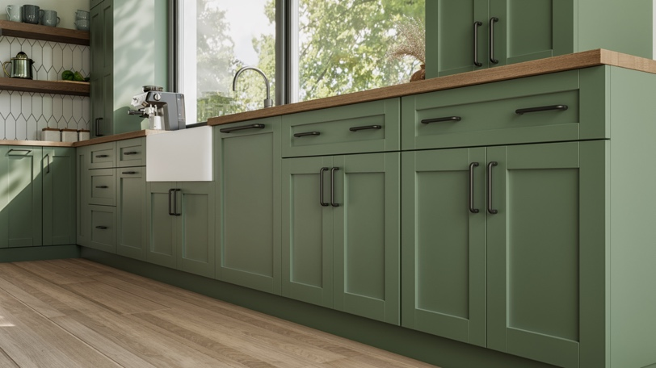
Soft, rounded corners paired with gear-like detailing create a subtle juxtaposition between strength and softness—the result is a collection that feels both modern and inviting, perfect for spaces that blend styles.

- 48 collection pieces
- Pulls available in sizes ranging from 3-3/4” c-c to 12” c-c
- Appliance pulls available in size 12” c-c and 18” c-c
- Finishes: Matte Black (BL), Brushed Nickel (BRN), Polished Chrome (CH), Polished Nickel (PN), Slate (SL) and Warm Brass (WB)

To access the full Atlas Homewares 2026 press kit, click here.

ABOUT ATLAS HOMEWARES

Since 1993, Atlas Homewares has been recognized by industry professionals and consumers as the go-to decorative hardware collection to bring fashion and style into a home. Atlas Homewares has been named numerous times as one of the Top 10 Preferred Decorative Hardware Brands by Kitchen & Bath Business magazine.

Over the past three decades, Atlas Homewares has introduced many top-selling collections that are featured in showcase houses and high-design installations nationally and internationally. The brand's impassioned designs are a collective expression of the team's love for architecture and fashion. Inspiration can come from the texture of leather, a bauble, a piece of coral or elements that many would overlook. Yet our team turns these design details into decorative hardware that makes a difference.

Atlas Homewares products are available through professional kitchen and bath showrooms across the United States and Canada. https://www.atlashomewares.com/

